History KS1 Knowledge Organiser - Year 1 - Victorians

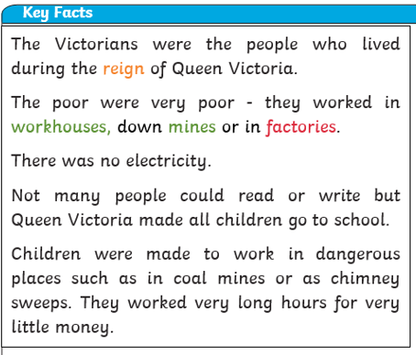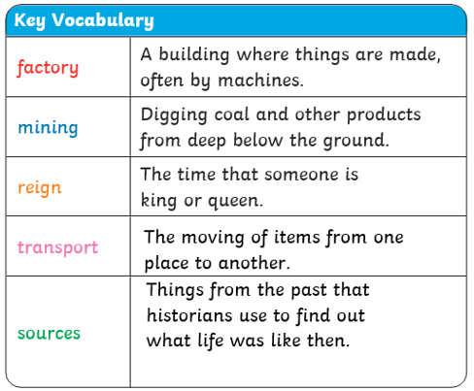

|  |
| --- |
| **What I should already know** |
| * That we have a king or Queen who reigns over the United Kingdom * That things happened before I was born * I know that the past means things that have already happened and the present is now |

|  |
| --- |
| **What I will learn (Sticky knowledge)** |
| 1. To know that the Victorian era was over 200 years ago 2. Know that Queen Victoria was the Queen during that time 3. To know what life was like for children during the Victorian times 4. Know that a lot of changes happened in England during the Victorian era 5. Describe the similarities and differences between Victorian schools and schools today |

