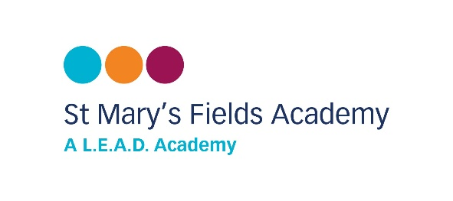
January 2025
Dear Parents/Carers
Hawthorn and Rowan visit to the Curve Theatre, Leicester
Friday 7th March 2025
We are looking to take the children in Hawthorn and Rowan classes to the Curve to watch “The Very Hungry Caterpillar”, to support our curriculum learning on the subject of mini beasts.

Your child will need to come to school for 8:40am as usual. They will leave school at 9:45am and travel by bus to the theatre for the 10:30am show. When they return to school they will eat their lunch. Home time collection will be at the usual time. All children must wear school uniform.

The charge for the trip is £19.50 per child, which includes the theatre ticket and transport.

If the school does not receive sufficient payments the trip may need to be cancelled.

Please consent and pay online via ParentPay, by Monday 3rd February 2025, or speak to Mrs Linnell/ Mrs Sandhu in the office if you need a barcode.

Yours sincerely
Mrs Morris and Miss Lee
……………………………………………………………………………………………………………………………
REPLY SLIP
I/We consent to my/our child taking part in the visit to the Curve Theatre, Leicester on Friday 7th March 2025 and have consented and paid online a voluntary contribution of £19.50.
Signed __________________________________________________________ Parent/Guardian
Print name_______________________________________________________ Parent/Guardian
Print name of child_________________________________________________
Class _________________________

