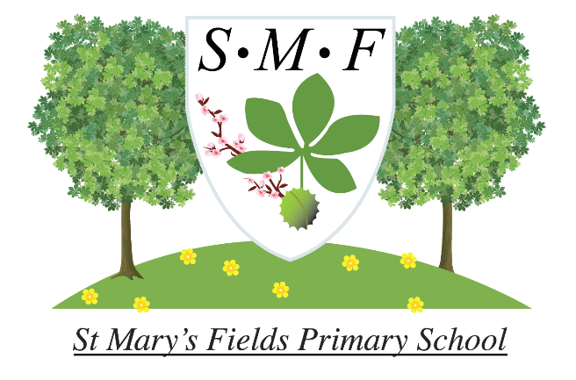

**English as an Additional Language**

**EAL Policy**

|  |  |  |  |  |  |  |
| --- | --- | --- | --- | --- | --- | --- |
| **Policy Date:** | March 2021 |  | **Version:** Summer Term 2021 **Subject lead:** Olivia Heath | | | |
| **Policy Review Date:** | March 2023 | Mrs R Dulieu (Head teacher) | Signature | | Date |
| **Ratified by Governing Body:** | | | | | | |
| Name: Raj Gill-Harrison | | | Signature | | Date | |

# 1. Definitions

A learner of English as an additional language (EAL) is a pupil whose first language is other than English.

*'First language is the language to which the child was initially exposed during early development and continues to use this language in the home and community. If a child acquires English subsequent to early development then English is not their first language no matter how proficient in it they become.'*

*Source: School census preparation and guidance for 2007 (DfES 2007)*

Pupils learning English as an additional language (EAL) share many common characteristics with pupils whose first language is English. However, their learning experience differs because they are learning in and through another language, and because they may come from cultural backgrounds and communities that have different understandings and expectations of education, language and learning.

# 2. EAL intent

Our EAL intent has three key messages:

* Vocabulary is crucial and prioritised.

As clearly stated in our whole school intent, St Mary’s Fields recognises that the development of a robust vocabulary is essential for all children. We know that for our EAL children, they are not only learning English, but are required to learn through English, and so we take additional steps to ensure that they are equipped with the vocabulary they need to succeed. For all children, vocabulary is a powerful predictor of their academic success and financial security in later life and we therefore prioritise the instruction of vocabulary in every aspect of our curriculum.

* Diversity is celebrated.

At St Mary’s Fields we have the privilege of teaching children from all over the world, speaking over 30 languages. We celebrate this diversity, preparing our children to be positive members of multicultural Britain. This is reflected in our whole school intent:

Our curriculum provides the opportunity for children to learn more about their own culture and that of others, through sharing and celebrating similarities and differences between us all.

Through our character education, we build the values of inclusivity, empathy and respect. We also encourage children and their families to maintain their home languages, as we believe that multilingualism is an asset to our families.

* What’s good for EAL is good for all.

The close links between our EAL intent and whole school intent are a reflection of this message. We know that all children benefit from a curriculum which prioritises vocabulary and celebrates diversity. Our curriculum, which blends knowledge, skills and character education, is inclusive in its design. All children attending St Mary’s Fields benefit from the rich language and broad experiences which are embedded in their learning journeys.

# 3. Implementation of our EAL intent

* Vocabulary is crucial and prioritised.

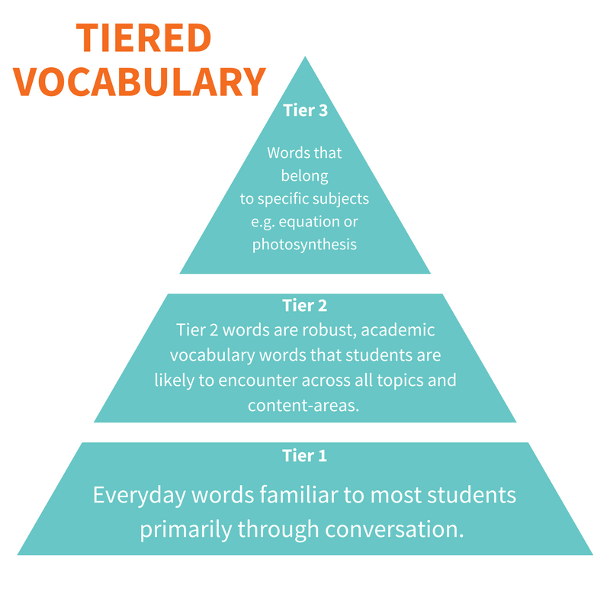

The school follows the Word Aware approach to teaching vocabulary. In every subject area, key “tier 2” vocabulary is selected, taught, applied and reviewed, according to the STAR approach. Vocabulary is celebrated in every classroom, with prominent word walls displaying recently acquired language, and key topic language featured on displays. We know that around 12 exposures to a word are needed in order for a child to retain it in their long-term memory. As a result, vocabulary teaching is filtered into everything we do. Crucially, our whole school curriculum emphasises the importance of children making links and learning words in new contexts:

Our curriculum ensures the children have the opportunity to make links within subjects, across subjects and to prior learning.

* Diversity is celebrated.

Each subject area at St Mary’s Fields is monitored to ensure that diversity is embedded. Children learn about both male and female historical figures, scientists, politicians and artists, from many different backgrounds and cultures, reflecting the diversity of our own school. Our PSHE curriculum is designed to celebrate children’s similarities and differences, building children’s self-esteem and self-efficacy. Immigration, a theme which is a personal experience of many of our children, is explored across the school as part of our history curriculum. Everyone’s Welcome resources are used in each year group, promoting discussions of inclusivity, and children are encouraged to find their own voice, particularly through our Votes for Schools assemblies. Importantly, new arrivals at St Mary’s Fields are welcomed through a carefully-designed induction process, detailed in Appendix A.

* What’s good for EAL is good for all.

# 3. Legislation and guidance

This policy reflects the requirements of the [National Curriculum programmes of study](https://www.gov.uk/government/collections/national-curriculum), which all maintained schools in England must teach.

This policy reflects requirements for inclusion and equality as set out in the [Special Educational Needs and Disability Code of Practice 2014](https://www.gov.uk/government/publications/send-code-of-practice-0-to-25) and [Equality Act 2010](http://www.legislation.gov.uk/ukpga/2010/15/part/6/chapter/1), and refers to curriculum-related expectations of governing boards set out in the Department for Education’s [Governance Handbook](https://www.gov.uk/government/publications/governance-handbook).

# 4. Roles and responsibilities

**4.1 EAL Co-ordinator:**

* Work with the headteacher and governors to determine the strategic development of the EAL policy and provision in the school
* Have day-to-day responsibility for the operation of this EAL policy and the co-ordination of specific provision made to support pupils who speak English as an additional language, including those who are new arrivals
* Provide professional guidance to colleagues and work with staff, parents, and other agencies to ensure that pupils who speak English as an additional language receive appropriate support and high quality teaching
* Work with the headteacher and governing board to ensure that the school meets its responsibilities under the Equality Act 2010 with regard to reasonable adjustments and access arrangements
* Ensure the school keeps the records of all pupils who speak English as an additional language up to date, including accurate induction records for new arrivals

**4.2 The governing board**

The governing board will:

* Monitor the quality and effectiveness of EAL provision within the school
* Work with the headteacher and EAL coordinator to determine the strategic development of the EAL policy and provision in the school

**4.3 The headteacher**

The headteacher will:

* Work with the EAL coordinator and governing board to determine the strategic development of the EAL policy and provision in the school
* Have overall responsibility for the provision and progress of learners who speak English as an additional language

**4.4 Class teachers**

Each class teacher is responsible for:

* The progress and development of every pupil in their class
* Working closely with any teaching assistants or specialist staff to plan and assess the impact of support and interventions and how they can be linked to classroom teaching
* Providing a supportive, welcoming start for any new arrivals
* Working with the EAL coordinator to review each pupil’s progress and development and decide on any changes to provision
* Ensuring they follow this EAL policy

# 5. Inclusion

Inclusive practice for EAL learners is explicitly stated in the National Curriculum:

4.5 Teachers must also take account of the needs of pupils whose first language is not English. Monitoring of progress should take account of the pupil’s age, length of time in this country, previous educational experience and ability in other languages.

4.6 The ability of pupils for whom English is an Additional Language to take part in the national curriculum may be in advance of their communication skills in English. Teachers should plan teaching opportunities to help pupils develop their English and should aim to provide the support pupils need to take part in all subjects.

Learners speaking English as an additional language may also have other needs and differences. It is essential that cognitive challenge for all EAL learners is appropriate. Having limited English does not mean that a child is a low-attainer. This is why effective assessment is essential for all EAL learners.

Teachers will use appropriate assessment to set ambitious targets and plan challenging work for all EAL pupils, including:

* More able pupils
* Pupils with low prior attainment
* Pupils from disadvantaged backgrounds
* Pupils with SEN
* Pupils who are new arrivals

EAL learners have equal access to the school’s provision, including to SEN provision and the provision for more able pupils, as appropriate.

# 6. Monitoring arrangements

* Effectiveness of the policy will be monitored by the EAL coordinator: learning walks, pupil interviews, work scrutinies, data analysis, case studies, and scrutiny of knowledge organisers will all aid this monitoring.
* The headteacher and the EAL coordinator will review this policy every two years. At every review, the policy will be shared with the governing board.

# 7. Links with other policies

This policy links to the following policies and procedures: The Assessment Policy & The Teaching & Learning Policy. Inclusion?